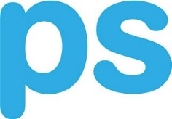
•
raising
of education
the power

educational services school health programs training/education

Name of Webinar Viewed:
Date Viewed:

How did you hear about this Webinar?

How useful was the information that was presented in the webinar today?
  - Very Useful?
  - Useful?
  - Neutral?
  - Not Useful?

Please describe one new valuable idea you received today.

I would like to see a future webinar on:

Would you like us to contact you to discuss ways PSI services can benefit your organization?

2112 Case Pkwy Twinsburg, Ohio 44087. South, #10 • P.O. Box 468
800.841.4774 • fax 330.425.2905
www.psi-solutions.org • info@psi-solutions.org

